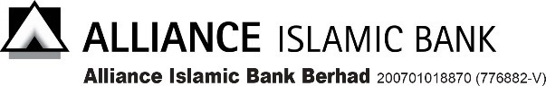
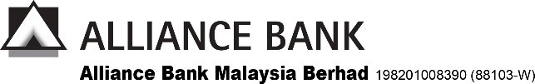

SERVICE REQUEST FORM
Company Information
Company Name

We would like the Bank to perform the following request for BizSmart® with immediate effect.
- USER MAINTENANCE
User Info: | Request type (please tick where applicable)
User ID :  Name :  I/C No. :  *Please note that mobile token will be assigned to user by default for user creation.  **User having incompatible mobile device with BizSmart® Mobile App may request hardware token.  RM70 will be imposed per hardware token. | Self-Manage |  | Bank Manage
 | 1. Regenerate  Password  (ePIN will be sent to registered Email)  2. Update Mobile No.  3. Update Email  4. Delete User | 5. Create New User as:  System Administrator*  System Authoriser*  Tel No.:  Email:  Hardware token**  6. Link User to access the above company as:  (only applicable for existing  user ID)  Maker [Finance/Payroll/All]  Authoriser [A/B/C/All]  Observer  System Administrator  System Authoriser  Checker [Finance/Payroll/All] | 1. Regenerate  Password  (ePIN will be sent to registered Email)  2. Update Mobile No.  3. Update Email  4. Delete User | 5. Create New User as:  Maker* [Finance/Payroll/All] Authoriser* [A/B/C/All]  Checker* [Finance/Payroll/All]  Observer*  Tel No.:  Email:  Hardware token**  6. Link User to access the above company as:  (only applicable for existing  user ID)  Maker [Finance/Payroll/All]  Authoriser [A/B/C/All]  Observer  Checker [Finance/Payroll/All]

Note: Please attach a separate sheet of paper for additional users

ENA B. CORPORATE MAINTENANCE
Please tick [] for any of the following request.

Link Account Delink Account Link Merchant ID Delink Merchant ID
Account/ID No.1 | Account/ID No.2 | Account/ID No.3

Change of Alliance BizSmart® Module (For Existing Alliance BizSmart® Transactional Module customers ONLY)
BizSmart® SME Solution (Only for SME & Sole Proprietor) | Standard Package | Others:
BizSmart® Termination

Update Contact Person Details / BizSmart® Mailing Address (We cannot deliver to P.O. Box address)

Additional Token Request _____Token(s) (Bank is authorised to debit RM70.00 per token from designated account)

(Bank is authorised to debit RM70.00 per token from designated account)
User ID: | User ID: | User ID:
Additional Token Request
___Token(s) for existing user

Token Replacement (Bank is authorised to debit RM50 per hardware token replacement)
The token replacement request is for the following user:
1. | Name: | I.C. No.: | User ID:
2. | Name: | I.C. No.: | User ID:

New Daily Corporate Limit Maintenance
Non – Trade: RM | Bulk Payment: RM

Pre-Account Registration – Favourite Account (Please attach a separate sheet of paper for additional account)
Beneficiary Preferred Name | Beneficiary Bank | Beneficiary/Biller Name | Beneficiary Account/ Card/Bill Account No | Request
□ Alliance Bank to Alliance Bank’s Account
□ IBG (Alliance Bank to Other’s Bank Account)
□ DuitNow Transfer (Instant Transfer/Pay to account)
□ Pay Bills/Card

AUTHORISED SIGNATORY(IES) |  |  |  | FOR BRANCH USE
 |  |  |  | CIF:
 |  |  |  | Verified By:
Name: | Name: | Company Stamp |  | Name: | Branch Stamp

For Alliance Bank’s Use Only and Strictly Private & Confidential. Universal SRF - Version 2.0

